BWHEG Guided Walks Programme
Spring - Summer 2020

We're offering another regular programme of FREE guided walks exploring and enjoying the Blaenavon Heritage Landscape

Some walks will be best for reasonably fit adults, but others will be suitable for older children or people with limited mobility. They will range in distance from around 5 to 12 km
(3 - 7 miles).

All of the walks will start from the Blaenavon World Heritage Centre, at 10.00 a.m. on the last Sunday of each month.

Please wear appropriate footwear and be prepared in case of wet weather (not unknown hereabouts!).

If you'd like to be involved in leading or helping with our guided walks programme, why not join BWHEG and become part of the team?
BWHEG Guided Walks Programme

Spring and Summer Walks 2020

1. 23rd February 2020, starting at 10.00 a.m.

"On the Level(s)"

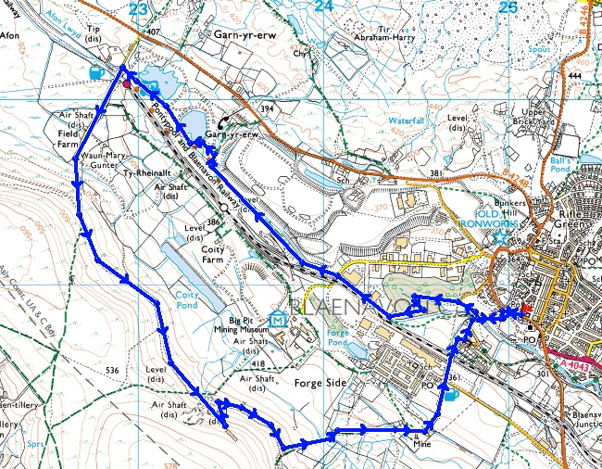

A fairly strenuous walk of about 7.5 km (4^{1/2} miles), suitable for older children, but not recommended for young children or people with limited mobility. This walk passes old coal and iron workings en route to The Whistle Inn and then follows a hillside track. We visit the site of a drift mine which only closed in 2009. We then descend the path to Forgeside and back to the World Heritage Centre.

Some parts can be very muddy in wet weather, so appropriate footwear is needed.
Spring and Summer Walks 2020
2. 29th March 2020, starting at 10.00 a.m.

"The Dog Stone "

The Dog Stone on Varteg Hill is a monument to the memory of Carlo, a red setter accidentally shot during a grouse shoot in 1864. The "stone" is an iron monument, cast in Blaenafon.

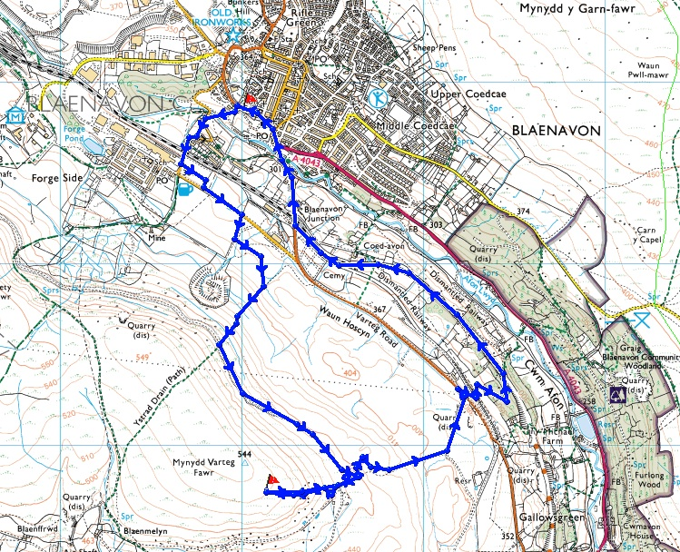

This is a short(ish) walk of about 8 km (5 miles), but with a couple of steep ascents (and, of course, descents!) It is suitable for older children, but could be difficult for people with limited mobility. We'll walk up to Forgeside, then up Varteg Hill to the Dog Stone. Then we'll walk down to join the old railway track (now the SUSTRANS cycle way) back to the World Heritage Centre.

Some parts can be muddy in wet weather, so appropriate footwear is needed.
Spring and Summer Walks 2020
3. 26th April 2020, Starting at 10.00 a.m.

"The Reed Beds in Spring"

This is a short and easy walk of about 7 km (4½ miles) in which we will focus on wildlife and some of the conservation work carried out by BWHEG. It will include pond-dipping and so should be fun for children.

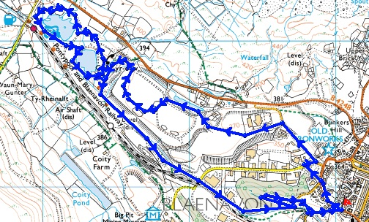

Leaving the World Heritage Centre, we shall walk past the industrial estate to visit a conservation pond and various wildlife havens such as the reed beds and an open area set up as a conservation site for ground-nesting birds. We'll then walk round Garn Lakes and back to base following the cycle path.

Some parts can be muddy in wet weather, so appropriate footwear is needed (wellies will do).
Spring and Summer Walks 2020
4. 31st May 2020, starting at 10.00 a.m.

"Meet the Neighbours"

A longish trip over Coety Mountain to Cwm Celyn.

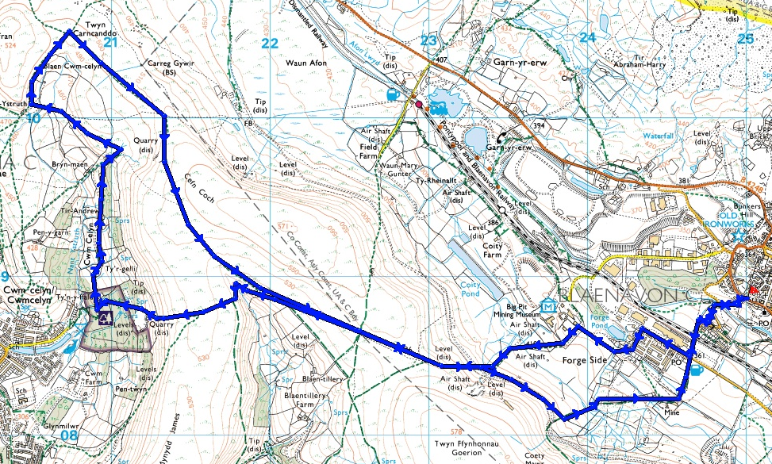

A long walk of about 14 km (9 miles). There are some steep ascents and descents, so it's unsuitable for younger children and people with limited mobility. The walk introduces our neighbouring valley and some of its interesting antiquities, dating back to the Bronze Age.

Appropriate footwear and waterproof gear are needed. You might like to bring a packed lunch.

Spring and Summer Walks 2020
5. 28th June 2020, starting at 10.00 a.m.

"Hidden Forgeside"

We'll celebrate World Heritage Week with this family-friendly local walk.

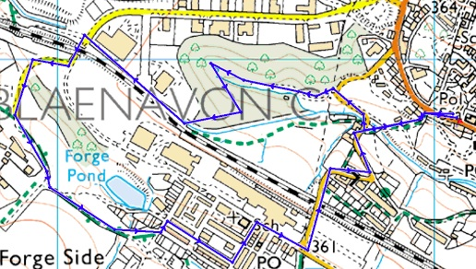

A very short walk of about 4 km (2½ miles) and suitable for families and people with limited mobility. The walk introduces a part of Blaenavon which grew up around the early iron industry and which is still important today. If the weather's fine, we'll extend the walk to Coity Tips.

You can obtain a leaflet about this route from the World Heritage Centre

